**Video about VMs and Containers**

Time spent: 60 min

**Differences between VMs and Containers and deep diving**

* The VM is a hardware abstraction: it takes physical CPUs and RAM from a host, and divides and shares it across several smaller virtual machines. There is an OS and application running inside the VM, but the virtualization software usually has no real knowledge of that.
* A container is an application abstraction: the focus is really on the OS and the application, and not so much the hardware abstraction. Many customers actually use both VMs and containers today in their environments and, in fact, may run containers inside of VMs.

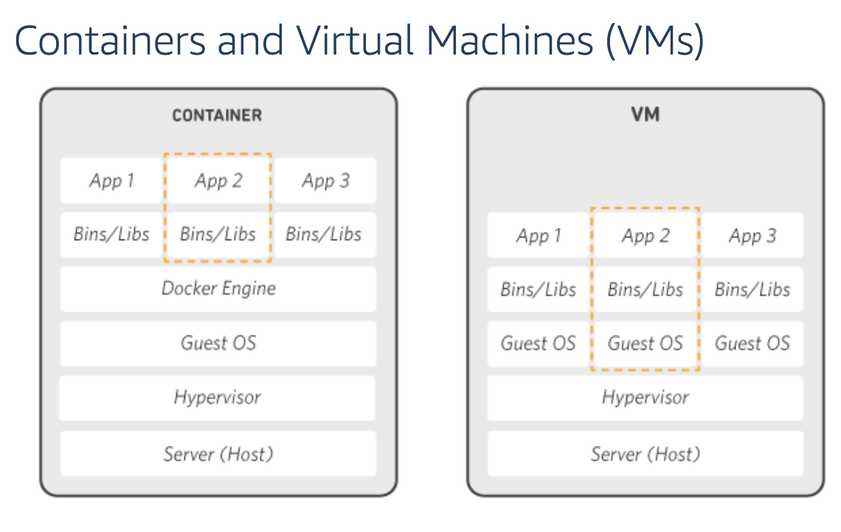

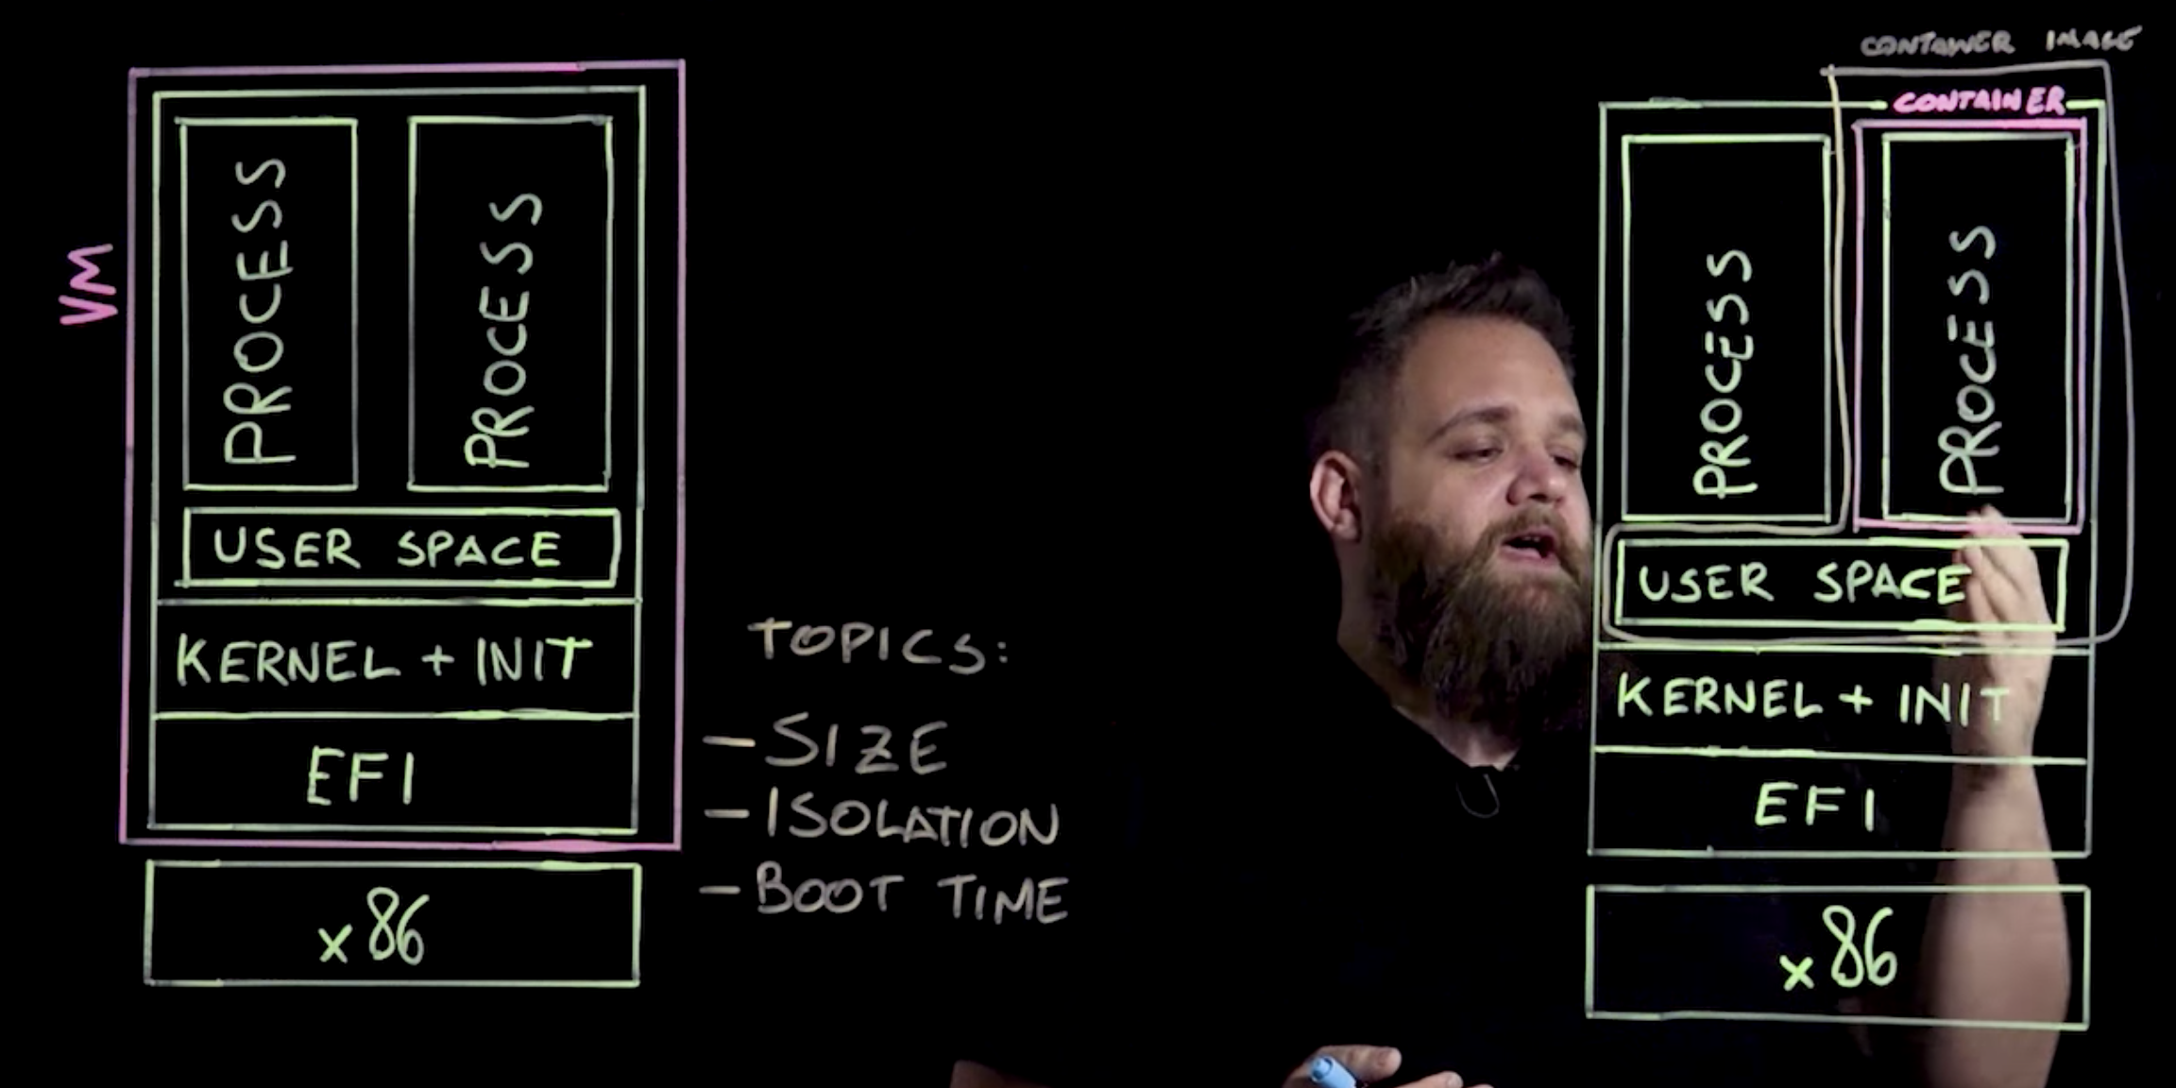

**What are Containers**

Containers are a method of operating system virtualization that allow you to run an application and its dependencies in resource-isolated processes. Containers allow you to easily package an application's code, configurations, and dependencies into easy to use building blocks that deliver environmental consistency, operational efficiency, developer productivity, and version control.

**Summary**

In this section, I have learned the detailed knowledge about containers, which helps me have a deeper understand of VMs and containers